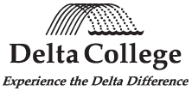

MERCHANDISE RETURN

PURCHASING DEPT, B-116
1961 DELTA ROAD
UNIVERSITY CENTER, MI 48710
(989) 686-9208

TO:
DATE:
P.O. #:
ACCOUNT # (Delta use)

REASON FOR RETURN | # PKGS. | SHIPPED VIA

QTY | DESCRIPTION | INV # | DATE | PRICE

Prepared by: |  | Copies: | Vendor  General Services  Purchasing

